**Game 24/7 - Guesstimate**

1. Problem Statement
2. Learning Objective
3. Prerequisites
4. References
5. Approach
6. Thought Process
7. Logic Building
   1. Thumb Rules
   2. Newly Launched Game
      1. Assumptions
      2. Calculations
   3. Already Established Game
      1. Assumptions
      2. Calculations
8. **Problem Statement**

**Games 24/7** had launched an arena based first person shooting game back in the year 2020. The game became very popular among the users in a very short span of time. Now the company intends to launch a similar game where they’re introducing a brand new map and some other cool features as well.

You, as a **Product Analyst** hired by Games 24/7, have to prepare a pricing strategy for them, where the Winner gets prize money Rs. 1 lakh and the Runner up gets Rs. 50k for each gaming event.

**What should be the per game entry price for a single participant?**

1. **Learning Objectives**

The sole purpose of this guesstimate is to check -

* How structured is your approach?
* How comfortable are you with estimating numbers?
* Can you do back of the mind calculations and validate the numbers?

1. **Prerequisites**

Things that we need to know before starting with the estimation -

* Market share of the game.
* Region where we’re calculating the estimate.

1. **References**

* We will take reference from the existing game tournaments that are already happening in India.
* This year the overall pool prize for the BGMI tournament was around 1.5 Crs.
* CoD also has a similar prize pool of taking into account all the contests for the day.
* Comparing this with our problem statement shows that the price money is fairly low as compared to BGMI & CoD.

1. **Approach**

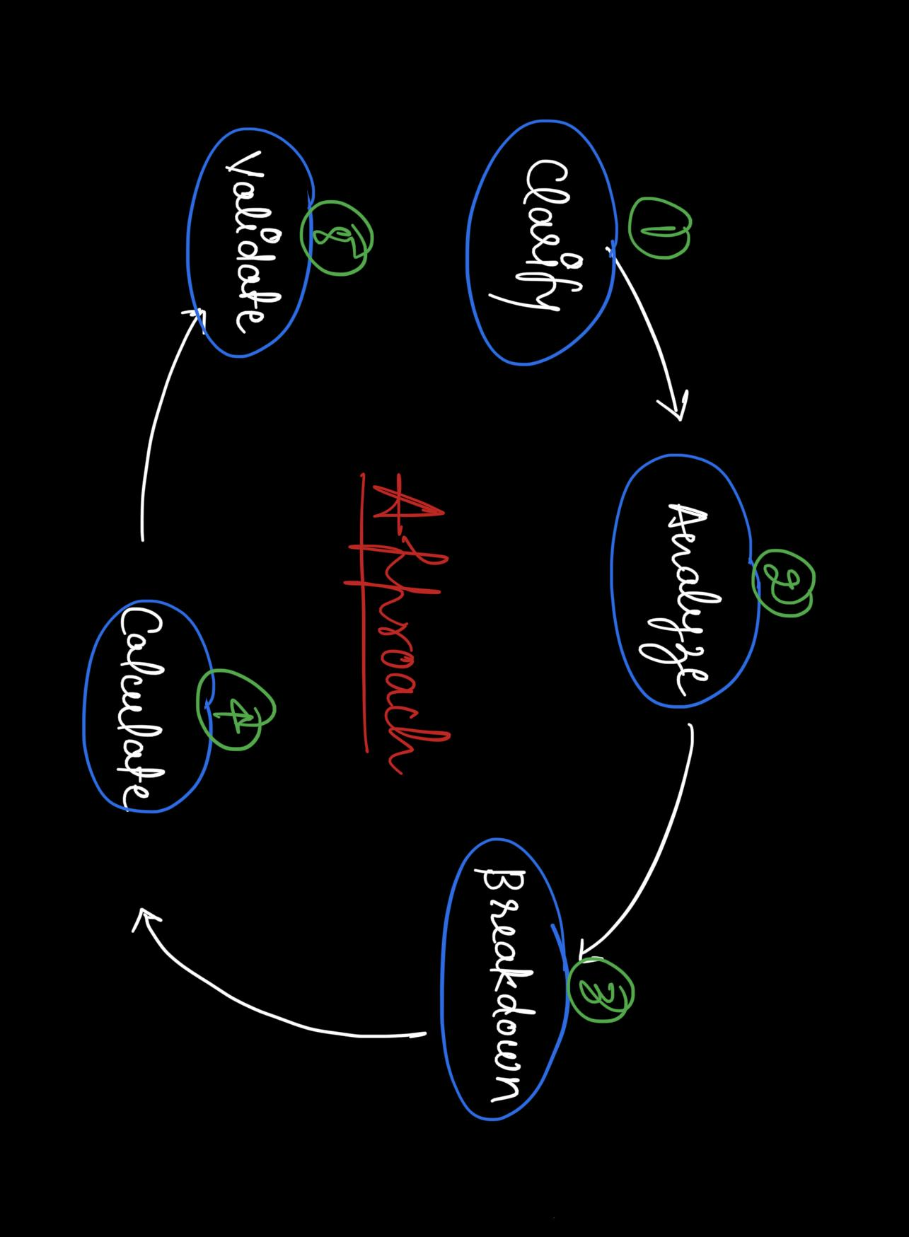

1. **Clarify** **-** First try to understand the problem statement and gather all the information required for the estimation.
2. **Analyze -** Analyze what all information you currently have and how you can use it to solve the problem in hand.
3. **Breakdown -** Decide a criteria and break things down into several categories. Smaller units are generally easier to deal with.
4. **Calculate -** Note down the assumptions and use them as thumb rules to make calculations. The numbers don’t need to be exact. Just specify a range or an approximation.
5. **Validate -** Finally, validate your results in terms of the business metric. Make sure that everything makes sense.
6. **Thought Process**
7. We can keep two separate gaming modes for free & cash players.
8. We can offer special upgrades (paid) to the players.
9. We can also earn by hosting advertisements on our platform.
10. We can allocate a separate budget for self promotion.
11. We’ll have to create a special team for application maintenance.
12. Hosting the server online will have a separate cost.
13. **Logic Building**

The idea is to classify the game into 2 different categories, one that has a larger market share and the other one which was launched recently and is relatively new in the gaming industry.

1. **Newly launched game**
2. **Already established game**

**7.1 Thumb Rules**

* We are considering the gaming event to be launched in India.
* The game is meant only for individual participants. Team entries are not allowed.

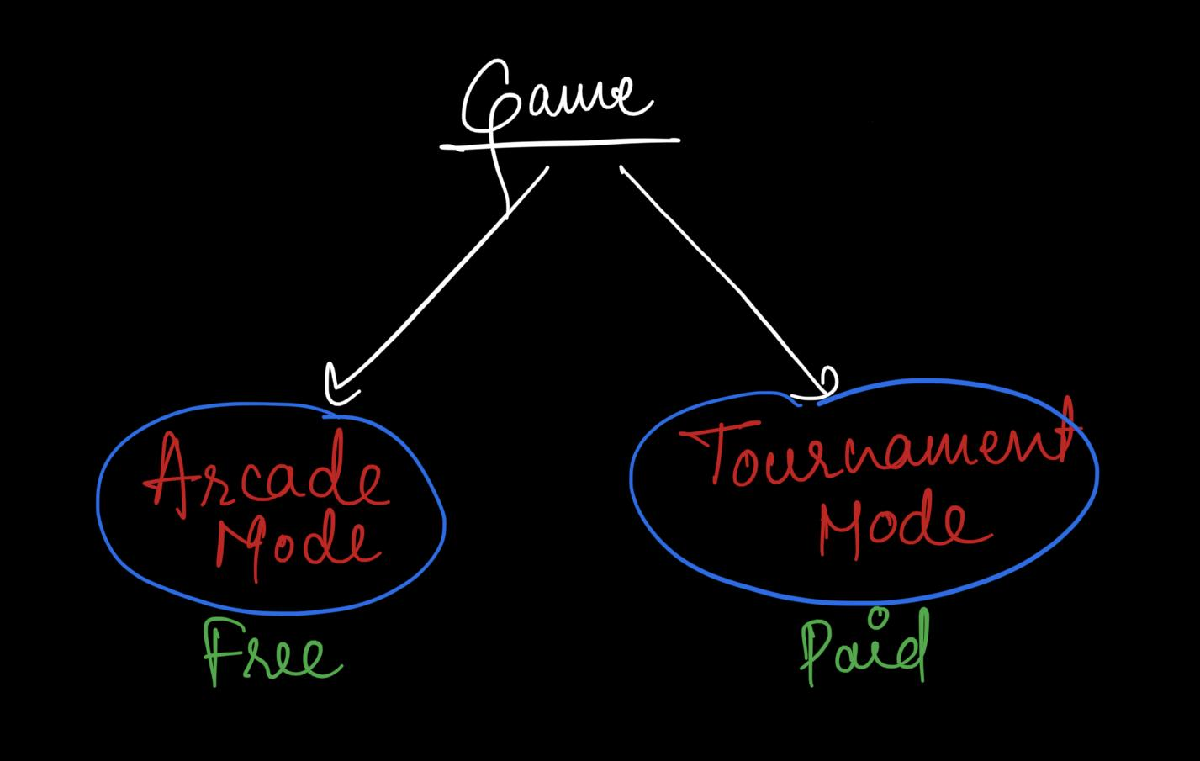

* The game will have two different gaming modes.

1. **Arcade** **mode** -
   1. This will be a practice lobby without any entry fee.
   2. No prizes will be given to the winners.
   3. The players can use this gaming mode to upskill themselves and increase their rank.
2. **Tournament mode** -
   1. This will be an open challenge for players around the company to compete against each other.
   2. Participants will have to pay an entry fee to join the tournament.

* **Royalty Cards** -
  + These upgrades will be offered to both free as well as cash players.
  + The special upgrades are only aesthetics like weapon skin, custom outfit, etc.
  + They do not give any advantage to the user.

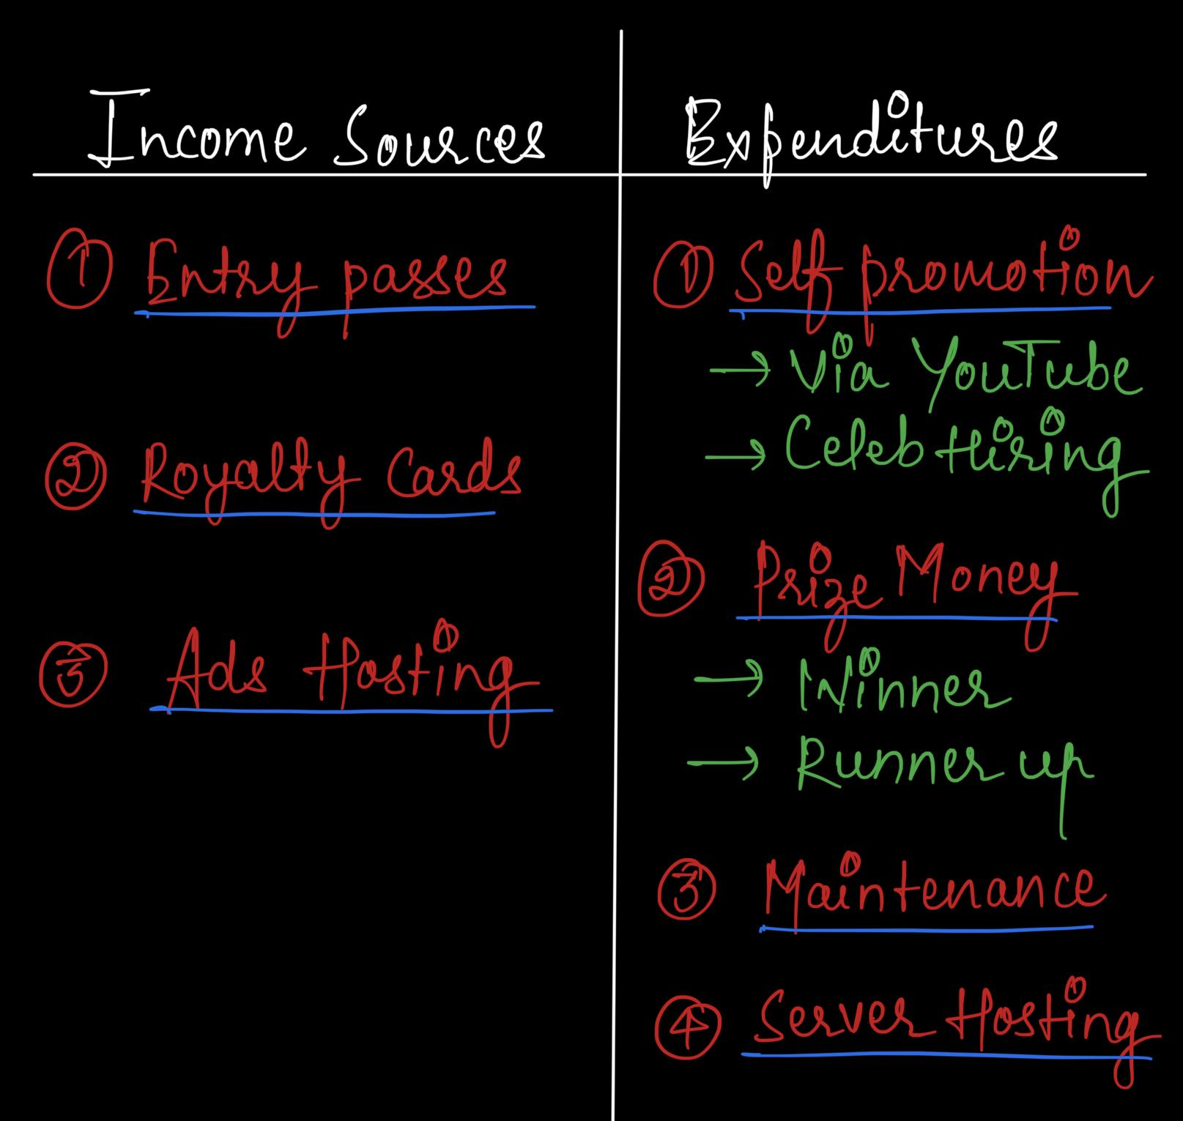

**7.2 Newly Launched Game -**

**7.2.1 Assumptions *(Parameters provided by the company)***

In order to proceed with our estimation, we first need to make some basic assumptions that’ll help us stick to a specific problem.

1. Since the market share of this game is relatively small, the number of **active users** on the platform will be **5k**.
2. 80% of the total active users will be free players. Only the rest **20% players** will participate in the **paid tournament.**
3. **15%** of the **combined total users** have purchased Royalty Cards that generate around **2.5k in revenue per user**.
4. The other 85% users haven’t purchased any upgrades.
5. No. of contests per day - **Daily 5 arcade games and 1 tournament** will be organized to engage more and more players.
6. **No advertisement** will be shown to the **tournament players**.
7. A **30 seconds ad** will be shown to the free players whenever they first open the game (**every day**) in **arcade mode**.
8. **Pricing** for the associated companies **to host a 30 seconds ad** on the platform will be **1 lakh**.
9. The company is planning to allocate a total amount of **4.5 lakhs/month for advertising** their game via YouTube, spending around **15k per day**.
10. To promote the product they might have to **hire celebrities** as well. So let’s say **5 lakhs (one time)** will be spent for such promotions.
11. **Maintenance cost** for the gaming application will be something around **3 lakhs/month** due to less no. of players.
12. To run the servers, cost will be relatively low in the beginning but since we have to **host servers** for both free & cash players let’s keep it around **5 lakhs/month**.

**7.2.2 Calculations**

1. **Incoming Cash Flow**

* Total no. of active users = *5k* *(from pt. i)*
* No. of paid users = *20% of 5k = 1k* *(from pt. ii)*
* Let the entry price for each game in Tournament mode be x
* Total amount received from users = No. of paid users * Entry price per game = *1k * x*
* Revenue generated from Royalty Card purchasers = *15% of 5k = (0.15 * 5,000) * 2,500 = 18.75 lakhs (from pt. iii)*
* Revenue generated from ad hosting = No. of ads * No. of days * Cost price for each ad = *1 * 30 * 1 lakh = 30 lakhs* *(from pt. vii , viii)*
* **Total income generated** = Income from entry price + Revenue from Royalty Cards + Revenue from ad hosting = *1k * x + 18.75 lakhs + 30 lakhs = 1000 x + 48.75 lakhs*

1. **Outgoing Cash Flow**

* Total prize money for a game = prize money for winner + prize money for runner up = *1+0.5 = 1.5 lakhs*
* Total prize money for a month with 1 contest per day = *30 * 1 * 1.5 = 45 lakhs*
* Budget for promotions = No. of days * Expenditure per day + Celeb fee = *30 * 15k + 5 lakhs = 9.5 lakhs (from pt. ix, x)*
* **Total expenditure** = Maintenance + Server Hosting + Promotions + Prize money = *3+5+9.5+45 = 62.5 lakhs* *(from pt. xi, xiii)*

1. **Equating the incoming & outgoing cash amount -**

1k * x + 48.75 lakhs = 62.5 lakhs

1k * x + = (62.5 - 48.75) lakhs

1k * x = 13.75 lakhs

x =13,75,000/1,000

x = 1,375

Therefore, the entry price for a single participant, for each game would be **Rs. 1375/-**

**7.3 Already Established Game -**

**7.3.1 Assumptions *(Parameters provided by the company)***

In order to proceed with our estimation, we first need to make some basic assumptions that’ll help us stick to a specific problem.

1. Since the market share of this game is relatively large, the number of **active users** on the platform will be **25k**.
2. 90% of the total active users will be free players. Only the rest **10% players** will participate in the **paid tournament**.
3. **5%** of the **combined total users** have purchased Royalty Cards that generate around **2.5k in revenue per user**.
4. The other 95% users haven’t purchased any upgrades.
5. No. of contests per day - **Daily 10 arcade games and 3 tournaments** will be organized to engage more and more players.
6. **No advertisement** will be shown to the **tournament players**.
7. A **20 seconds ad** will be shown to the free players whenever they first open the game (**every day**) in **arcade mode**.
8. **Pricing** for the associated companies **to host a 20 seconds ad** on the platform will be **1 lakhs**.
9. Since the game is already popular, the company spends a relatively small amount (**1.5 lakhs/month** or around **5k per day**) on advertisements.
10. **Maintenance cost** for the gaming application is high, something around **15 lakhs/month**.
11. To **run the servers**, cost will also be high (around **25 lakhs/month**).

**7.3.2 Calculations**

1. **Incoming Cash Flow**

* Total no. of active users = *25k (from pt. i)*
* No. of paid users = *10% of 25k = 2.5k* *(from pt. ii)*
* Let the entry for each game in Tournament mode be x
* Total amount received from users = No. of paid users * No. of tournaments * Entry price per game = *2.5k * 3 * x = 7.5 * x*
* Revenue generated from Royalty Card purchasers = *5% of 25k = (0.05 * 25,000) * 2,500 = 31.25 lakhs* *(from pt. iii)*
* Revenue generated from ad hosting = No. of ads * No. of days * Cost price for each ad = *1 * 30 * 1 lakh = 30 lakhs* *(from pt. vii, viii)*
* **Total income generated** = Income from entry price + Revenue from Royalty Cards + Revenue from ad hosting = *7.5k * x + 31.25 lakhs + 30 lakhs = 7.5k * x + 61.25 lakhs*

1. **Outgoing Cash Flow**

* Total prize money for a game = prize money for winner + prize money for runner up = *1+0.5 = 1.5 lakhs*
* Total prize money for a month with 1 contest per day = *30 * 1 * 1.5 = 45 lakhs*
* Budget for promotions = No. of days * Expenditure per day = *30 * 5k = 1.5 lakhs* *(from pt. ix)*
* **Total expenditure** = Maintenance + Server Hosting + Promotions + Prize money = *15+25+1.5+45 = 81.5 lakhs (from pt. x, xi)*

1. **Equating the incoming & outgoing cash amount -**

7.5k * x + 61.25 lakhs = 81.5 lakhs

7.5k * x + = (81.5 - 61.25) lakhs

7.5k * x = 20.25 lakhs

x = 20,25,000/7,500

x = 270

Therefore, the entry price for a single participant, for each game would be **Rs. 270/-**